Ex no: 12 | Developing a webpage using javascript
Date : | Developing a webpage using javascript

Question:1
Write a JavaScript function to find the sum of first n odd numbers and display the Result:.Get the
value of n from the user

Aim::
To Write a JavaScript function to find the sum of first n odd numbers and display the Result:.Get the
value of n from the user

Code::
<html>
<head>
<link rel="stylesheet" type="text/css" href="c.css">
</head>
<body>
<h2>The sum of n odd numbers</h2>
<script>
var n = Number(prompt("Enter N"));
add(n);
function add(n){
var i=0;
var n1=n;
var sum=0;
for(i=1;i<=n1;i++){
if(i%2!=0){
sum=sum+i;}}
document.write("n: ",n);
document.write("<br>sum: ",sum);}
</script>
</body>
</html>
Output
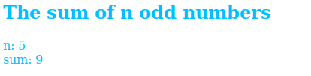

Result:
Thus web page has been successfully developed and the output was verified.
Ex no: 12 | Developing a webpage using javascript
Date : | Developing a webpage using javascript

Question:2
Write a JavaScript function that checks occurence of substring in a given string

Aim:
To Write a JavaScript function that checks occurence of substring in a given string

Code:
<html>
<body>
<script>
var s=prompt("Enter string");
var s1=prompt("Enter substring");
if(s.search(s1)==0)
document.write("substring ",s1," is present in string ",s);
else
document.write("substring ",s1," is not present in string ",s);
</script>
</body>
</html>

Output
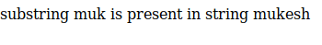

Result:
Thus web page has been successfully developed and the output was verified.

Ex no: 12 | Developing a webpage using javascript
Date : | Developing a webpage using javascript

Question:3
Write a JavaScript function that accepts a string as a parameter and converts the first letter of
each word of the string in upper case

Aim:
To Write a JavaScript function that accepts a string as a parameter and converts the first letter of
each word of the string in upper case

Code:
<html>
<body>
<script>
function uppercase(str)
{
var arr = str.split(' ');
var arr1 = [];

for(var x = 0; x < arr.length; x++){
arr1.push(arr[x].charAt(0).toUpperCase()+arr[x].slice(1));
}
return arr1.join(' ');
}
a=prompt("ENter String to change");
document.write("given string is ",a,"<br>",uppercase(a));
</script>
</body>
</head>
Output:
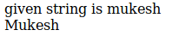

Result:
Thus web page has been successfully developed and the output was verified.
Ex no: 13 | Developing a webpage using javascript
Date : | Developing a webpage using javascript

Question:1
Write a JavaScript program that displays the position of the first occurrence of "World" in the
variable txt

Aim:
To Write a JavaScript program that displays the position of the first occurrence of "World" in the
variable txt

Code:
<html>
<body>
<script>
a=prompt("ENter String ");
b=prompt("ENter String for inddex check");
var n = a.indexOf(b);
document.write(n);
</script>
</body>
</head>

Output

Result:
Thus web page has been successfully developed and the output was verified.

Ex no: 13 | Developing a webpage using javascript
Date : | Developing a webpage using javascript

Question:2
Write a JavaScript function to remove specified number of characters from a string

Aim:
To Write a JavaScript function to remove specified number of characters from a string

Code:
<script>
function rem(str, char_pos)
{
a = str.substring(0,str.length-char_pos);
return a;
}
b=prompt("Enter string");
document.write(rem(b,3))
</script>
Output

Result:
Thus web page has been successfully developed and the output was verified.
Ex no: 13 | Developing a webpage using javascript
Date : | Developing a webpage using javascript

Question:3
Create an HTML page with a textbox and a command button:When the user gives a number and presses the Calculate button, it has to alert the sum.

Aim:
To Create an HTML page with a textbox and a command button:When the user gives a number and presses the Calculate button, it has to alert the sum.

Code:
<html>
<head>
<script>
function fun(){
var n=document.getElementById("#").value;
var d=n.split('');
var sum=0;
for(i=0;i<d.length;i++){
sum=sum+Number(d[i]);]
alert(sum);]
</script>
<body>
<form>
<p>Text Box <input type="text" id="#" placeholder="Enter someting">
<button type="button" onclick="fun()">Click Here!</button>
</form>

Output
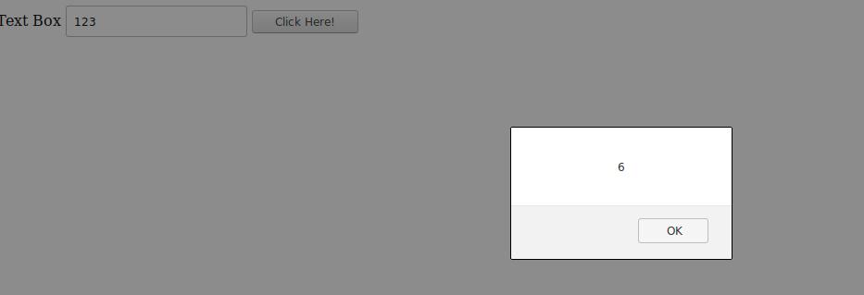

Result:
Thus web page has been successfully developed and the output was verified.
Ex no: 14 | Developing a webpage using Regular Expression
Date : | Developing a webpage using Regular Expression

Question:1
Write a JavaScript program to check an Aadhar number(Format :9999-9999-9999)

Aim:
To Write a JavaScript program to check an Aadhar number(Format :9999-9999-9999)

Code:
<html>
<head>
<script type="text/javascript">
a=prompt("Enter aadhar nos");
is(a);
function is(str){
var creditPattern = /^\d{4}-\d{4}-\d{4}$/;
if (creditPattern.test(str)){
alert("Correct");}
else{
alert("Incorrect format");}}
</script>
</head>
Output:

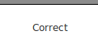

Result:
Thus web page has been successfully developed and the output was verified.
Ex no: 14 | Developing a webpage using Regular Expression
Date : | Developing a webpage using Regular Expression

Question:2
Write a JavaScript function that checks occurence of substring in a given string

Aim:
To Write a JavaScript function that checks occurence of substring in a given string

Code:
<html>
<head>
<script>
function validate(email,ph){
var email=document.getElementById("mk").value;
var ph=document.getElementById("mk1").value;
var emailp = /^[a-zA-Z0-9._-]+@[a-zA-Z0-9.-]+\.[a-zA-Z]{2,4}$/;
var phone = /^\d{10}$/;
if(emailp.test(email)==1 && phone.test(ph)==1)
alert("Email and Phone Number are correct format");
else
alert("In Correct");}
</script>
</head>
<body>
<form>
<p>Email:<input type="text" id="mk" placeholder="Enter Email">
<p>Phone Number:<input type="text" id="mk1" placeholder="Enter phone number">
<button type="button" onclick="validate()">Click Here!!!</button>
</body>
</html>

Output

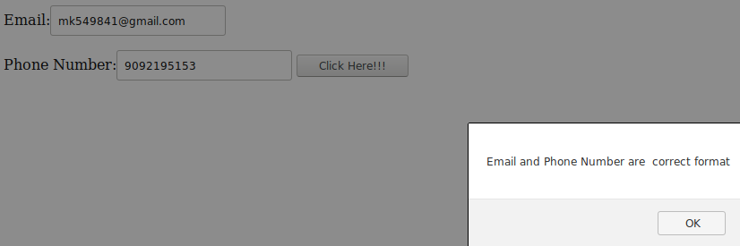

Result:
Thus web page has been successfully developed and the output was verified.

Ex no: 15 | Creating XML document for given data
Date : | Creating XML document for given data

Question:1
Create XML document for the following data: Student Registration Form Name Rahul Age 16 Gender Male Course C Programming

Aim:
To Create XML document for the following data: Student Registration Form Name Rahul Age 16 Gender Male Course C Programming

Code:
<<?xml version="1.0" ?>
<StudentRegistrationForm>
<name>Rahul</name>
<Age>"16></Age>
<Gender>Male</Gender>
<Course>C Programming</Course>
</StudentRegistrationForm>
</html>

Output

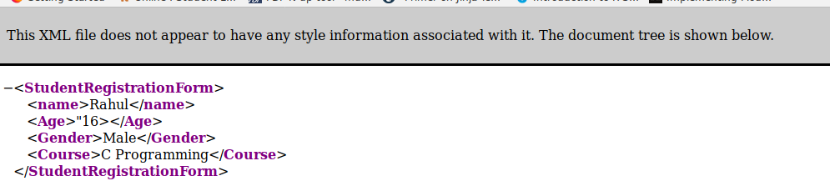

Result:
Thus web page has been successfully developed and the output was verified.
Ex no: 15 | Creating XML document for given data
Date : | Creating XML document for given data

Question:2
Check whether the following XML documents are well formed. If it is not well formed, correct the errors. <?xml version="1.0" encoding="iso-8859-1"?> <message> <email> <header> <sender>me@wipro.com</sender> <recipient>you@wipro.com</recipient> </header> <subject>Re: XML </subject> <text>I'm working on XML now. </email> </Messag

Aim:
To Check whether the following XML documents are well formed

Code:
<<?xml version="1.0" encoding="iso-8859-1"?>
<message>
<email>
<header>
<sender>me@wipro.com</sender>
<recipient>you@wipro.com</recipient>
</header>
<subject>Re: XML </subject>
<text>I'm working on XML now.</text>
</email>
</message>

Output

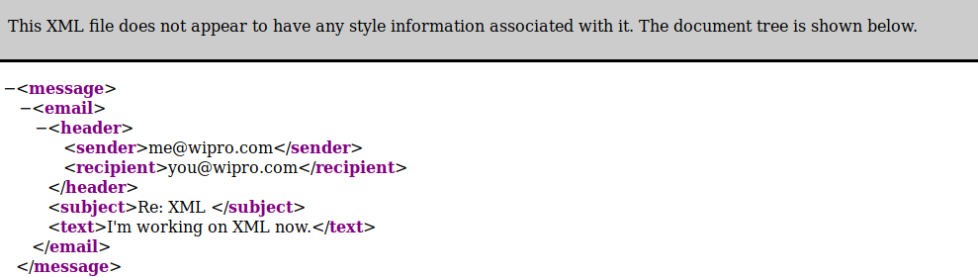

Result:
Thus web page has been successfully developed and the output was verified.
Ex no: 15 | Creating XML document for given data
Date : | Creating XML document for given data

Question:3
Develop DTD for the below given XML document: <address> <name>Manju</name> <company>Wipro</company> <phone>9988776655</phone> </address>

Aim:
To Develop DTD for the below given XML document: <address> <name>Manju</name> <company>Wipro</company> <phone>9988776655</phone> </address>

Code:
<?xml version="1.0"?>
<!DOCTYPE note [
<!ELEMENT address (name,company,phone)>
<!ELEMENT name (#PCDATA)>
<!ELEMENT company (#PCDATA)>
<!ELEMENT phone (#PCDATA)>
]>
<address>
<name>Manju</name>
<company>Wipro</company>
<phone>"9092191952"</phone>
</address>
Output:

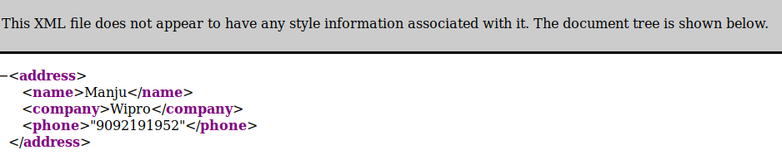

Result:
Thus web page has been successfully developed and the output was verified.
Ex no: 16 | Develop a DTD file for given XML document
Date : | Develop a DTD file for given XML document

Question:1
Develop DTD file for the below given XML document:
<?xml version="1.0"?>
<?xml-stylesheet href="catalog.xsl" type="text/xsl"?>
<!DOCTYPE catalog SYSTEM "catalog.dtd">
<catalog>
<product description="Cardigan Sweater" product_image="cardigan.jpg">
<catalog_item gender="Men's">
<item_number>QWZ5671</item_number>
<price>39.95</price>
<size description="Medium">
<color_swatch image="red_cardigan.jpg">Red</color_swatch>
<color_swatch image="burgundy_cardigan.jpg">Burgundy</color_swatch>
</size>
<size description="Large">
<color_swatch image="red_cardigan.jpg">Red</color_swatch>
<color_swatch image="burgundy_cardigan.jpg">Burgundy</color_swatch>
</size>
</catalog_item>
<catalog_item gender="Women's">
<item_number>RRX9856</item_number>
<price>42.50</price>
<size description="Small">
<color_swatch image="red_cardigan.jpg">Red</color_swatch>
<color_swatch image="navy_cardigan.jpg">Navy</color_swatch>
<color_swatch image="burgundy_cardigan.jpg">Burgundy</color_swatch>
</size>
<size description="Medium">
<color_swatch image="red_cardigan.jpg">Red</color_swatch>
<color_swatch image="navy_cardigan.jpg">Navy</color_swatch>
<color_swatch image="burgundy_cardigan.jpg">Burgundy</color_swatch>
<color_swatch image="black_cardigan.jpg">Black</color_swatch>
</size>
<size description="Large">
<color_swatch image="navy_cardigan.jpg">Navy</color_swatch>
<color_swatch image="black_cardigan.jpg">Black</color_swatch>
</size>
<size description="Extra Large">
<color_swatch image="burgundy_cardigan.jpg">Burgundy</color_swatch>
<color_swatch image="black_cardigan.jpg">Black</color_swatch>
</size>
</catalog_item>
</product>
</catalog>

Aim:
To Develop DTD file for the above given XML document:

Code:
<<?xml version="1.0" encoding="UTF-8"?>
<?xml-stylesheet href="4.xsl" type="text/xsl"?>
<!DOCTYPE catalog SYSTEM "4.dtd">

<catalog>
<product description="Cardigan Sweater" product_image="cardigan.jpg">

<catalog_item gender="Men's">
<item_number>QWZ5671</item_number>
<price>39.95</price>
<size description="Medium">
<color_swatch image="rose-blue-flower-rose-blooms-67636.jpg">Red</color_swatch>
<color_swatch image="burgundy_cardigan.jpg">Burgundy</color_swatch>
</size>

<size description="Large">
<color_swatch image="red_cardigan.jpg">Red</color_swatch>
<color_swatch image="burgundy_cardigan.jpg">Burgundy</color_swatch>
</size>
</catalog_item>

<catalog_item gender="Women's">

<item_number>RRX9856</item_number>
<price>42.50</price>
<size description="Small">
<color_swatch image="red_cardigan.jpg">Red</color_swatch>
<color_swatch image="navy_cardigan.jpg">Navy</color_swatch>
<color_swatch image="burgundy_cardigan.jpg">Burgundy</color_swatch>
</size>

<size description="Medium">
<color_swatch image="red_cardigan.jpg">Red</color_swatch>
<color_swatch image="navy_cardigan.jpg">Navy</color_swatch>
<color_swatch image="burgundy_cardigan.jpg">Burgundy</color_swatch>
<color_swatch image="black_cardigan.jpg">Black</color_swatch>
</size>

<size description="Large">
<color_swatch image="navy_cardigan.jpg">Navy</color_swatch>
<color_swatch image="black_cardigan.jpg">Black</color_swatch>
</size>

<size description="Extra Large">
<color_swatch image="burgundy_cardigan.jpg">Burgundy</color_swatch>
<color_swatch image="black_cardigan.jpg">Black</color_swatch>
</size>

</catalog_item>
</product>
</catalog>

Output

Result:
Thus web page has been successfully developed and the output was verified.

Ex no: 16 | Develop a DTD file for given XML document
Date : | Develop a DTD file for given XML document

Question:2
Develop an XML file following the DTD file given below:
<!DOCTYPE TVSCHEDULE [
<!ELEMENT TVSCHEDULE (CHANNEL+)>
<!ELEMENT CHANNEL (BANNER,DAY+)>
<!ELEMENT BANNER (#PCDATA)>
<!ELEMENT DAY (DATE,(HOLIDAY|PROGRAMSLOT+)+)>
<!ELEMENT HOLIDAY (#PCDATA)>
<!ELEMENT DATE (#PCDATA)>
<!ELEMENT PROGRAMSLOT (TIME,TITLE,DESCRIPTION?)>
<!ELEMENT TIME (#PCDATA)>
<!ELEMENT TITLE (#PCDATA)>
<!ELEMENT DESCRIPTION (#PCDATA)>
<!ATTLIST TVSCHEDULE NAME CDATA #REQUIRED>
<!ATTLIST CHANNEL CHAN CDATA #REQUIRED>
<!ATTLIST PROGRAMSLOT VTR CDATA #IMPLIED>
<!ATTLIST TITLE RATING CDATA #IMPLIED>
<!ATTLIST TITLE LANGUAGE CDATA #IMPLIED>
]>
Aim:
To Develop an XML file following the DTD file given above

Code:
<?xml version="1.0"?>
<!DOCTYPE TVSCHEDULE [
<!ELEMENT TVSCHEDULE (CHANNEL+)>
<!ELEMENT CHANNEL (BANNER,DAY+)>
<!ELEMENT BANNER (#PCDATA)>
<!ELEMENT DAY (DATE,(HOLIDAY|PROGRAMSLOT+)+)>
<!ELEMENT HOLIDAY (#PCDATA)>
<!ELEMENT DATE (#PCDATA)>
<!ELEMENT PROGRAMSLOT (TIME,TITLE,DESCRIPTION?)>
<!ELEMENT TIME (#PCDATA)>
<!ELEMENT TITLE (#PCDATA)>
<!ELEMENT DESCRIPTION (#PCDATA)>
<!ATTLIST TVSCHEDULE NAME CDATA #REQUIRED>
<!ATTLIST CHANNEL CHAN CDATA #REQUIRED>
<!ATTLIST PROGRAMSLOT VTR CDATA #IMPLIED>
<!ATTLIST TITLE RATING CDATA #IMPLIED>
<!ATTLIST TITLE LANGUAGE CDATA #IMPLIED>
]>

<TVSCHEDULE NAME="vehicle launch">
<CHANNEL CHAN="111">
<BANNER> APACHE </BANNER>
<DAY>
<DATE>11/12/2019</DATE>
<HOLIDAY> YES </HOLIDAY>
<PROGRAMSLOT VTR="333">
<TIME RATING="7.9">10:35a.m</TIME>
<TITLE LANGUAGE="english"> HAHAHAH </TITLE>
<DESCRIPTION > BIKE REVIEWS </DESCRIPTION>
</PROGRAMSLOT>
</DAY>
</CHANNEL>
</TVSCHEDULE>
Output

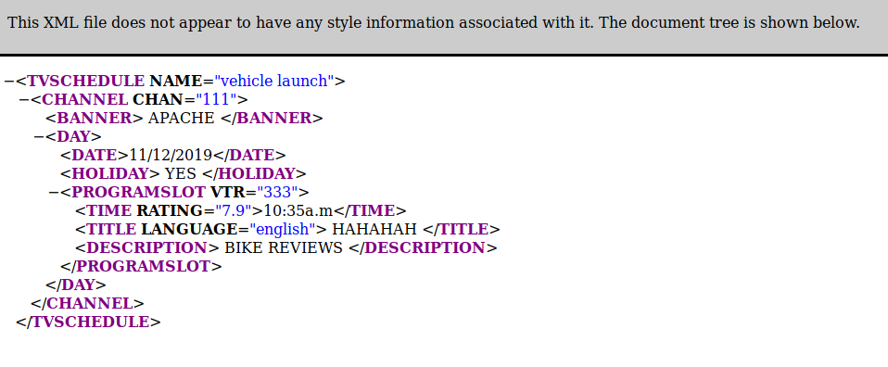

Result:
Thus web page has been successfully developed and the output was verified.
Ex no: 17 | Developing a XML document to avoid Naming conflits
Date : | Developing a XML document to avoid Naming conflits

Question:1
Avoid Naming conflict in the following XML document:
<Phone>
<name>Moto E</name>
<ModelNo>123</ModelNo>
<Processor> Qualcomm Snapdragon 200 </Processor>
<Battery>2390 mAh</Battery>
</Phone>
<Phone>
<name>Beetel M71 Landline</name>
<ModelNo>456</ModelNo>
<Display>LCD Screen</Display>
<Corded>Yes</Corded>
</Phone>

Aim:
To Avoid Naming conflict in the above XML document:

Code:
<?xml version="1.0" encoding="UTF-8"?>
<Phone>
<s1:mobile xmlns:s1 = "www.google.com">
<s1:name>Moto E</s1:name>
<s1:ModelNo>123</s1:ModelNo>
<s1:Processor> Qualcomm Snapdragon 200 </s1:Processor>
<s1:Battery>2390 mAh</s1:Battery>
</s1:mobile>
<s2:mobile1 xmlns:s2 = "www.google.com">
<s2:name>Beetel M71 Landline</s2:name>
<s2:ModelNo>456</s2:ModelNo>
<s2:Display>LCD Screen</s2:Display>
<s2:Corded>Yes</s2:Corded>
</s2:mobile1>
</Phone>

Output

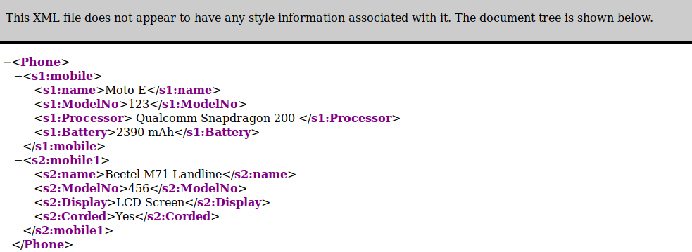

Result:
Thus web page has been successfully developed and the output was verified.
Ex no: 18 | Develop a Schema file for a given XML file
Date : | Develop a Schema file for a given XML file

Question:1
Create and XSD file for the XML document given in the DTD

Aim:
To Create and XSD file for the XML document given in the DTD

Code:
<?xml version="1.0" ?>
<xs:schema xmlns:xs="http://www.w3.org/20001/XMLSchema.com">
<xs:element name="StudentRegistrationForm">
<xs:complexType>
<xs:sequence>
<xs:element name="name" type="xs:string"/>
<xs:element name="age" type="xs:int"/>
<xs:element name="Gender" type="xs:string"/>
<xs:element name="Course" type="xs:string"/>
</xs:sequence>
</xs:complexType>
</xs:element>
</xs:schema>
Output:

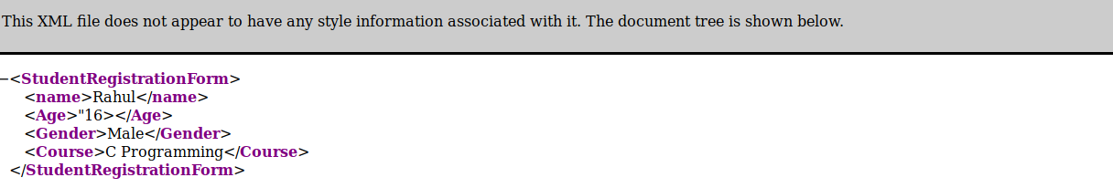

Result:
Thus web page has been successfully developed and the output was verified.
Ex no: 18 | Develop a Schema file for a given XML file
Date : | Develop a Schema file for a given XML file

Question:2
Create an XSD file for the XML document given in the DTD

Aim:
To Create an XSD file for the XML document given in the DTD

Code:
<?xml version="1.0" ?>
<xs:schema xmlns:xs="http://www.w3.org/20001/XMLSchema.com">
<xs:element name="message">
<xs:complexType>
<xs:sequence>
<xs:element name="email">
<xs:complexType>
<xs:sequence>
<xs:element name="sender" type="xs:string"/>
<xs:element name="recipient" type="xs:string"/>
</xs:sequence>
</xs:complexType>
</xs:element>
<xs:element name="subject" type="xs:string"/>
<xs:element name="text" type="xs:string"/>
</xs:sequence>
</xs:complexType>
</xs:element>
</xs:schema>
Output:
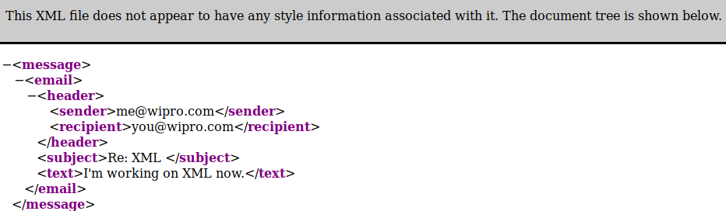
Result:
Thus web page has been successfully developed and the output was verified.

Ex no: 19 | Develop a webpage using Flask with HTML
Date : | Develop a webpage using Flask with HTML

Question:1
Write a JavaScript function to find the sum of first n odd numbers and display the Result:.Get the
value of n from the user

Aim::
To Write a JavaScript function to find the sum of first n odd numbers and display the Result:.Get the
value of n from the user

Code::
<html>
<head>
<link rel="stylesheet" type="text/css" href="c.css">
</head>
<body>
<h2>The sum of n odd numbers</h2>
<script>
var n = Number(prompt("Enter N"));
add(n);
function add(n){
var i=0;
var n1=n;
var sum=0;
for(i=1;i<=n1;i++){
if(i%2!=0){
sum=sum+i;}}
document.write("n: ",n);
document.write("<br>sum: ",sum);}
</script>
</body>
</html>
Output

Result:
Thus web page has been successfully developed and the output was verified.
Ex no: 12 | Developing a webpage using javascript
Date : | Developing a webpage using javascript

Question:2
Write a JavaScript function that checks occurence of substring in a given string

Aim:
To Write a JavaScript function that checks occurence of substring in a given string

Code:
<html>
<body>
<script>
var s=prompt("Enter string");
var s1=prompt("Enter substring");
if(s.search(s1)==0)
document.write("substring ",s1," is present in string ",s);
else
document.write("substring ",s1," is not present in string ",s);
</script>
</body>
</html>

Output

Result:
Thus web page has been successfully developed and the output was verified.

Ex no: 12 | Developing a webpage using javascript
Date : | Developing a webpage using javascript

Question:3
Write a JavaScript function that accepts a string as a parameter and converts the first letter of
each word of the string in upper case

Aim:
To Write a JavaScript function that accepts a string as a parameter and converts the first letter of
each word of the string in upper case

Code:
<html>
<body>
<script>
function uppercase(str)
{
var arr = str.split(' ');
var arr1 = [];

for(var x = 0; x < arr.length; x++){
arr1.push(arr[x].charAt(0).toUpperCase()+arr[x].slice(1));
}
return arr1.join(' ');
}
a=prompt("ENter String to change");
document.write("given string is ",a,"<br>",uppercase(a));
</script>
</body>
</head>
Output:

Result:
Thus web page has been successfully developed and the output was verified.
Ex no: 13 | Developing a webpage using javascript
Date : | Developing a webpage using javascript

Question:1
Write a JavaScript program that displays the position of the first occurrence of "World" in the
variable txt

Aim:
To Write a JavaScript program that displays the position of the first occurrence of "World" in the
variable txt

Code:
<html>
<body>
<script>
a=prompt("ENter String ");
b=prompt("ENter String for inddex check");
var n = a.indexOf(b);
document.write(n);
</script>
</body>
</head>

Output

Result:
Thus web page has been successfully developed and the output was verified.

Ex no: 13 | Developing a webpage using javascript
Date : | Developing a webpage using javascript

Question:2
Write a JavaScript function to remove specified number of characters from a string

Aim:
To Write a JavaScript function to remove specified number of characters from a string

Code:
<script>
function rem(str, char_pos)
{
a = str.substring(0,str.length-char_pos);
return a;
}
b=prompt("Enter string");
document.write(rem(b,3))
</script>
Output

Result:
Thus web page has been successfully developed and the output was verified.
Ex no: 13 | Developing a webpage using javascript
Date : | Developing a webpage using javascript

Question:3
Create an HTML page with a textbox and a command button:When the user gives a number and presses the Calculate button, it has to alert the sum.

Aim:
To Create an HTML page with a textbox and a command button:When the user gives a number and presses the Calculate button, it has to alert the sum.

Code:
<html>
<head>
<script>
function fun(){
var n=document.getElementById("#").value;
var d=n.split('');
var sum=0;
for(i=0;i<d.length;i++){
sum=sum+Number(d[i]);]
alert(sum);]
</script>
<body>
<form>
<p>Text Box <input type="text" id="#" placeholder="Enter someting">
<button type="button" onclick="fun()">Click Here!</button>
</form>

Output

Result:
Thus web page has been successfully developed and the output was verified.
Ex no: 14 | Developing a webpage using Regular Expression
Date : | Developing a webpage using Regular Expression

Question:1
Write a JavaScript program to check an Aadhar number(Format :9999-9999-9999)

Aim:
To Write a JavaScript program to check an Aadhar number(Format :9999-9999-9999)

Code:
<html>
<head>
<script type="text/javascript">
a=prompt("Enter aadhar nos");
is(a);
function is(str){
var creditPattern = /^\d{4}-\d{4}-\d{4}$/;
if (creditPattern.test(str)){
alert("Correct");}
else{
alert("Incorrect format");}}
</script>
</head>
Output:

Result:
Thus web page has been successfully developed and the output was verified.
Ex no: 14 | Developing a webpage using Regular Expression
Date : | Developing a webpage using Regular Expression

Question:2
Write a JavaScript function that checks occurence of substring in a given string

Aim:
To Write a JavaScript function that checks occurence of substring in a given string

Code:
<html>
<head>
<script>
function validate(email,ph){
var email=document.getElementById("mk").value;
var ph=document.getElementById("mk1").value;
var emailp = /^[a-zA-Z0-9._-]+@[a-zA-Z0-9.-]+\.[a-zA-Z]{2,4}$/;
var phone = /^\d{10}$/;
if(emailp.test(email)==1 && phone.test(ph)==1)
alert("Email and Phone Number are correct format");
else
alert("In Correct");}
</script>
</head>
<body>
<form>
<p>Email:<input type="text" id="mk" placeholder="Enter Email">
<p>Phone Number:<input type="text" id="mk1" placeholder="Enter phone number">
<button type="button" onclick="validate()">Click Here!!!</button>
</body>
</html>

Output

Result:
Thus web page has been successfully developed and the output was verified.

Ex no: 15 | Creating XML document for given data
Date : | Creating XML document for given data

Question:1
Create XML document for the following data: Student Registration Form Name Rahul Age 16 Gender Male Course C Programming

Aim:
To Create XML document for the following data: Student Registration Form Name Rahul Age 16 Gender Male Course C Programming

Code:
<<?xml version="1.0" ?>
<StudentRegistrationForm>
<name>Rahul</name>
<Age>"16></Age>
<Gender>Male</Gender>
<Course>C Programming</Course>
</StudentRegistrationForm>
</html>

Output

Result:
Thus web page has been successfully developed and the output was verified.
Ex no: 15 | Creating XML document for given data
Date : | Creating XML document for given data

Question:2
Check whether the following XML documents are well formed. If it is not well formed, correct the errors. <?xml version="1.0" encoding="iso-8859-1"?> <message> <email> <header> <sender>me@wipro.com</sender> <recipient>you@wipro.com</recipient> </header> <subject>Re: XML </subject> <text>I'm working on XML now. </email> </Messag

Aim:
To Check whether the following XML documents are well formed

Code:
<<?xml version="1.0" encoding="iso-8859-1"?>
<message>
<email>
<header>
<sender>me@wipro.com</sender>
<recipient>you@wipro.com</recipient>
</header>
<subject>Re: XML </subject>
<text>I'm working on XML now.</text>
</email>
</message>

Output

Result:
Thus web page has been successfully developed and the output was verified.
Ex no: 15 | Creating XML document for given data
Date : | Creating XML document for given data

Question:3
Develop DTD for the below given XML document: <address> <name>Manju</name> <company>Wipro</company> <phone>9988776655</phone> </address>

Aim:
To Develop DTD for the below given XML document: <address> <name>Manju</name> <company>Wipro</company> <phone>9988776655</phone> </address>

Code:
<?xml version="1.0"?>
<!DOCTYPE note [
<!ELEMENT address (name,company,phone)>
<!ELEMENT name (#PCDATA)>
<!ELEMENT company (#PCDATA)>
<!ELEMENT phone (#PCDATA)>
]>
<address>
<name>Manju</name>
<company>Wipro</company>
<phone>"9092191952"</phone>
</address>
Output:

Result:
Thus web page has been successfully developed and the output was verified.
Ex no: 16 | Develop a DTD file for given XML document
Date : | Develop a DTD file for given XML document

Question:1
Develop DTD file for the below given XML document:
<?xml version="1.0"?>
<?xml-stylesheet href="catalog.xsl" type="text/xsl"?>
<!DOCTYPE catalog SYSTEM "catalog.dtd">
<catalog>
<product description="Cardigan Sweater" product_image="cardigan.jpg">
<catalog_item gender="Men's">
<item_number>QWZ5671</item_number>
<price>39.95</price>
<size description="Medium">
<color_swatch image="red_cardigan.jpg">Red</color_swatch>
<color_swatch image="burgundy_cardigan.jpg">Burgundy</color_swatch>
</size>
<size description="Large">
<color_swatch image="red_cardigan.jpg">Red</color_swatch>
<color_swatch image="burgundy_cardigan.jpg">Burgundy</color_swatch>
</size>
</catalog_item>
<catalog_item gender="Women's">
<item_number>RRX9856</item_number>
<price>42.50</price>
<size description="Small">
<color_swatch image="red_cardigan.jpg">Red</color_swatch>
<color_swatch image="navy_cardigan.jpg">Navy</color_swatch>
<color_swatch image="burgundy_cardigan.jpg">Burgundy</color_swatch>
</size>
<size description="Medium">
<color_swatch image="red_cardigan.jpg">Red</color_swatch>
<color_swatch image="navy_cardigan.jpg">Navy</color_swatch>
<color_swatch image="burgundy_cardigan.jpg">Burgundy</color_swatch>
<color_swatch image="black_cardigan.jpg">Black</color_swatch>
</size>
<size description="Large">
<color_swatch image="navy_cardigan.jpg">Navy</color_swatch>
<color_swatch image="black_cardigan.jpg">Black</color_swatch>
</size>
<size description="Extra Large">
<color_swatch image="burgundy_cardigan.jpg">Burgundy</color_swatch>
<color_swatch image="black_cardigan.jpg">Black</color_swatch>
</size>
</catalog_item>
</product>
</catalog>

Aim:
To Develop DTD file for the above given XML document:

Code:
<<?xml version="1.0" encoding="UTF-8"?>
<?xml-stylesheet href="4.xsl" type="text/xsl"?>
<!DOCTYPE catalog SYSTEM "4.dtd">

<catalog>
<product description="Cardigan Sweater" product_image="cardigan.jpg">

<catalog_item gender="Men's">
<item_number>QWZ5671</item_number>
<price>39.95</price>
<size description="Medium">
<color_swatch image="rose-blue-flower-rose-blooms-67636.jpg">Red</color_swatch>
<color_swatch image="burgundy_cardigan.jpg">Burgundy</color_swatch>
</size>

<size description="Large">
<color_swatch image="red_cardigan.jpg">Red</color_swatch>
<color_swatch image="burgundy_cardigan.jpg">Burgundy</color_swatch>
</size>
</catalog_item>

<catalog_item gender="Women's">

<item_number>RRX9856</item_number>
<price>42.50</price>
<size description="Small">
<color_swatch image="red_cardigan.jpg">Red</color_swatch>
<color_swatch image="navy_cardigan.jpg">Navy</color_swatch>
<color_swatch image="burgundy_cardigan.jpg">Burgundy</color_swatch>
</size>

<size description="Medium">
<color_swatch image="red_cardigan.jpg">Red</color_swatch>
<color_swatch image="navy_cardigan.jpg">Navy</color_swatch>
<color_swatch image="burgundy_cardigan.jpg">Burgundy</color_swatch>
<color_swatch image="black_cardigan.jpg">Black</color_swatch>
</size>

<size description="Large">
<color_swatch image="navy_cardigan.jpg">Navy</color_swatch>
<color_swatch image="black_cardigan.jpg">Black</color_swatch>
</size>

<size description="Extra Large">
<color_swatch image="burgundy_cardigan.jpg">Burgundy</color_swatch>
<color_swatch image="black_cardigan.jpg">Black</color_swatch>
</size>

</catalog_item>
</product>
</catalog>

Output

Result:
Thus web page has been successfully developed and the output was verified.

Ex no: 16 | Develop a DTD file for given XML document
Date : | Develop a DTD file for given XML document

Question:2
Develop an XML file following the DTD file given below:
<!DOCTYPE TVSCHEDULE [
<!ELEMENT TVSCHEDULE (CHANNEL+)>
<!ELEMENT CHANNEL (BANNER,DAY+)>
<!ELEMENT BANNER (#PCDATA)>
<!ELEMENT DAY (DATE,(HOLIDAY|PROGRAMSLOT+)+)>
<!ELEMENT HOLIDAY (#PCDATA)>
<!ELEMENT DATE (#PCDATA)>
<!ELEMENT PROGRAMSLOT (TIME,TITLE,DESCRIPTION?)>
<!ELEMENT TIME (#PCDATA)>
<!ELEMENT TITLE (#PCDATA)>
<!ELEMENT DESCRIPTION (#PCDATA)>
<!ATTLIST TVSCHEDULE NAME CDATA #REQUIRED>
<!ATTLIST CHANNEL CHAN CDATA #REQUIRED>
<!ATTLIST PROGRAMSLOT VTR CDATA #IMPLIED>
<!ATTLIST TITLE RATING CDATA #IMPLIED>
<!ATTLIST TITLE LANGUAGE CDATA #IMPLIED>
]>
Aim:
To Develop an XML file following the DTD file given above

Code:
<?xml version="1.0"?>
<!DOCTYPE TVSCHEDULE [
<!ELEMENT TVSCHEDULE (CHANNEL+)>
<!ELEMENT CHANNEL (BANNER,DAY+)>
<!ELEMENT BANNER (#PCDATA)>
<!ELEMENT DAY (DATE,(HOLIDAY|PROGRAMSLOT+)+)>
<!ELEMENT HOLIDAY (#PCDATA)>
<!ELEMENT DATE (#PCDATA)>
<!ELEMENT PROGRAMSLOT (TIME,TITLE,DESCRIPTION?)>
<!ELEMENT TIME (#PCDATA)>
<!ELEMENT TITLE (#PCDATA)>
<!ELEMENT DESCRIPTION (#PCDATA)>
<!ATTLIST TVSCHEDULE NAME CDATA #REQUIRED>
<!ATTLIST CHANNEL CHAN CDATA #REQUIRED>
<!ATTLIST PROGRAMSLOT VTR CDATA #IMPLIED>
<!ATTLIST TITLE RATING CDATA #IMPLIED>
<!ATTLIST TITLE LANGUAGE CDATA #IMPLIED>
]>

<TVSCHEDULE NAME="vehicle launch">
<CHANNEL CHAN="111">
<BANNER> APACHE </BANNER>
<DAY>
<DATE>11/12/2019</DATE>
<HOLIDAY> YES </HOLIDAY>
<PROGRAMSLOT VTR="333">
<TIME RATING="7.9">10:35a.m</TIME>
<TITLE LANGUAGE="english"> HAHAHAH </TITLE>
<DESCRIPTION > BIKE REVIEWS </DESCRIPTION>
</PROGRAMSLOT>
</DAY>
</CHANNEL>
</TVSCHEDULE>
Output

Result:
Thus web page has been successfully developed and the output was verified.
Ex no: 17 | Developing a XML document to avoid Naming conflits
Date : | Developing a XML document to avoid Naming conflits

Question:1
Avoid Naming conflict in the following XML document:
<Phone>
<name>Moto E</name>
<ModelNo>123</ModelNo>
<Processor> Qualcomm Snapdragon 200 </Processor>
<Battery>2390 mAh</Battery>
</Phone>
<Phone>
<name>Beetel M71 Landline</name>
<ModelNo>456</ModelNo>
<Display>LCD Screen</Display>
<Corded>Yes</Corded>
</Phone>

Aim:
To Avoid Naming conflict in the above XML document:

Code:
<?xml version="1.0" encoding="UTF-8"?>
<Phone>
<s1:mobile xmlns:s1 = "www.google.com">
<s1:name>Moto E</s1:name>
<s1:ModelNo>123</s1:ModelNo>
<s1:Processor> Qualcomm Snapdragon 200 </s1:Processor>
<s1:Battery>2390 mAh</s1:Battery>
</s1:mobile>
<s2:mobile1 xmlns:s2 = "www.google.com">
<s2:name>Beetel M71 Landline</s2:name>
<s2:ModelNo>456</s2:ModelNo>
<s2:Display>LCD Screen</s2:Display>
<s2:Corded>Yes</s2:Corded>
</s2:mobile1>
</Phone>

Output

Result:
Thus web page has been successfully developed and the output was verified.
Ex no: 18 | Develop a Schema file for a given XML file
Date : | Develop a Schema file for a given XML file

Question:1
Create and XSD file for the XML document given in the DTD

Aim:
To Create and XSD file for the XML document given in the DTD

Code:
<?xml version="1.0" ?>
<xs:schema xmlns:xs="http://www.w3.org/20001/XMLSchema.com">
<xs:element name="StudentRegistrationForm">
<xs:complexType>
<xs:sequence>
<xs:element name="name" type="xs:string"/>
<xs:element name="age" type="xs:int"/>
<xs:element name="Gender" type="xs:string"/>
<xs:element name="Course" type="xs:string"/>
</xs:sequence>
</xs:complexType>
</xs:element>
</xs:schema>
Output:

Result:
Thus web page has been successfully developed and the output was verified.
Ex no: 18 | Develop a Schema file for a given XML file
Date : | Develop a Schema file for a given XML file

Question:2
Create an XSD file for the XML document given in the DTD

Aim:
To Create an XSD file for the XML document given in the DTD

Code:
<?xml version="1.0" ?>
<xs:schema xmlns:xs="http://www.w3.org/20001/XMLSchema.com">
<xs:element name="message">
<xs:complexType>
<xs:sequence>
<xs:element name="email">
<xs:complexType>
<xs:sequence>
<xs:element name="sender" type="xs:string"/>
<xs:element name="recipient" type="xs:string"/>
</xs:sequence>
</xs:complexType>
</xs:element>
<xs:element name="subject" type="xs:string"/>
<xs:element name="text" type="xs:string"/>
</xs:sequence>
</xs:complexType>
</xs:element>
</xs:schema>
Output:
Result:
Thus web page has been successfully developed and the output was verified.

